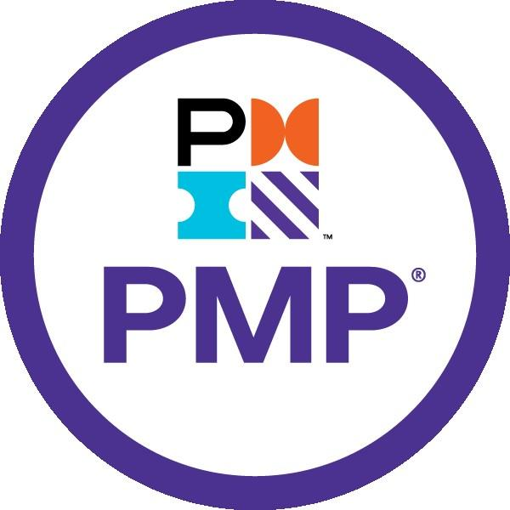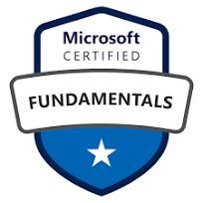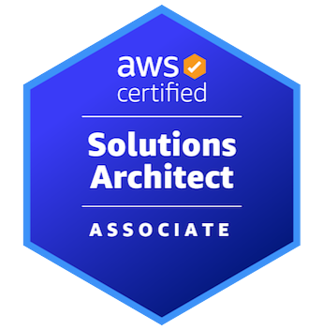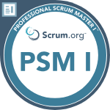

**SHAIKH**

**469 436 3510**

**sdhandapani@selsoftinc.com**

**Executive Summary**

* Certified PMP, Scrum Master, Microsoft Azure and AWS Solution Architect with overall experience of 19+ years in Project Management, PMO and IT Operations roles in Cloud Infrastructure, Investment Banking, Broker dealer service and Asset servicing.
* Acquainted with process related to **Project Management methodology** including estimation, project initiation and risk-analysis for integration of external systems.
* Technical skill set and expertise in **Agile methodology, Project management** and **Incident management**
* Extensive experience in developing Business Requirement Documents (BRD), Software Requirements Specification (SRS), Requirement Traceability Matrix (RTM).
* A team leader with demonstrated abilities in training & mentoring teams towards achievement of organizational goals
* Expert at driving the adoption and enforcement of Scrum rules, removing impediments and fostering self-management.
* Improved team velocity by incorporating capacity planning into sprint planning sessions.
* Facilitated Release Planning, Sprint Planning, Backlog Grooming, and Retrospective meetings
* Removed team impediments on a daily basis to allow the team to deliver the sprint goals and deliverables.
* Areas of expertise include:
  + Cloud Infrastructure
  + Risk Management with specialization in Cyber Risk
  + Process Optimization initiatives
  + Project Support Services
* Strong communication skills in engaging with Senior Stakeholders across US, EMEA and APAC
* Providing periodic status reports to the stakeholders, updating with current status of the projects and highlight any issues or risks.
* Proficient with executing several organizational wide Transformational Programs.

**Competencies**

|  |  |  |
| --- | --- | --- |
| * PMO * Agile Principles * Story-Based Development * Risk and Issues Management * Cyber Risk and Vulnerabilities Remediation | * MI Reporting and Dashboards * Service Level Management * Financial Management * Client Management * Vendor Management * Stakeholder Management | * Change Management * Incident Management * IT Operations * Technical Support |

**Tools, Technologies & Projects**

|  |  |  |
| --- | --- | --- |
| Tools | Project | Description |
| * Enterprise Project Management 2007 * Jira * ServiceNow * Confluence * SharePoint * MS-Office * Archer * Remedy | * Cloud infrastructure * Centralized repository * Digital Pulse Platform * SLM Project * Interactive Dashboard * Baseline Creation | Multiple Infrastructure projects on all the major Cloud tenants and OpenShift Containers.  Digital Pulse is a data lake and an Analytical Platform of BNYMellon.  Leverage Jira and confluence to provide holistic view of risk issue to senior management, which I extended to other SIRO in my LOB.  Service level Management – Providing attainment, stability and regulatory reports for all LOB’s.  Interactive Dashboard with real time data and automated reports generation.  Created Baseline for all divisions under LOB. |

**Education**

|  |  |  |
| --- | --- | --- |
| **Degree, Specialization** | **Institute** | **Graduated** |
| Bachelors in Information Technology | Manipal University | 2005 |

**Experience Snapshot**

|  |  |  |
| --- | --- | --- |
| **Period** | **Organization** | **Profile** |
| Apr’23 – Present | Selsoft Inc | Project Management Specialist – Cloud |
| Dec’21 – Apr’23 | Skillmine Technology | PMO - Cloud Infrastructure (Azure, GCP, OCS, and AWS) & OpenShift Containers |
| Apr’19 – Dec’21 | Request IT Services | Sr. Scrum master / Agile Project manager |
| Jul’09 – Mar’19 | BNY Mellon Technology | Project Lead |
| Jul’06 – Jun’09 | Sutherland Global Services | Subject Matter Expert (Microsoft Account) |
| Dec’05 – Jun’06 | 24/7 Customer | Technical Support Executive (Dell Account) |
| Mar’05 – Nov’05 | Calsoft Technologies | Customer Support Exec |

**Professional Experience**

|  |  |
| --- | --- |
| **UBS Bank, Chicago, IL, USA.** | |
| **Position** | **Project Management Specialist** |
| **Profile** | The project aimed to provide infrastructure for migration from on prem to Cloud (Azure, AWS, GCP, OCI). The goal was to migrate key projects to improve operational efficiency through scalability and flexibility, enhance performance and reliability by leveraging cloud infrastructure.   * Responsible for adhering to PMO best practices, standards and framework for cloud projects. * Coordinate with project managers and project coordinators to track project status and impediments. * Design, develop and maintain a detailed work breakdown of project milestones, deliverables and tasks to be accomplished for the initiative and ensure that tasks are accomplished on time. * Coordinate with project leads to take actions on open vulnerabilities (Ethical hack, Cyber security, etc), Compliance activities and other open tasks. * Spearheaded the implementation of SIEM, IAM, firewalls, and endpoint security solutions to enhance organizational security posture. * Prepared budget summary and track reports, processing business approvals for all Cloud tenant. * Managed various vendors for negotiation, SoW, contract renewal, Request for Proposal (RFP), processing business memo approvals and purchase orders. * Track and report on various business and internal projects, timelines, progress and resource allocations as required. * Communicate with project stakeholders and influence direction of participants to meet the overall project goals and objectives. * Drive collaboration and accountability with TIG Leads and Service Managers to develop and implement infrastructure projects in a complete and timely manner consistent with business needs. * Responsible for initiating project reviews, as well as aggregating and coordinating project reporting information into a program level communication / report suitable for management consumption and decision making purposes. * Coordinate and document RCAs for all major incidents related to cloud infra and security team. Also maintain RCA repository in SharePoint. * Track and report change activities performed by Cloud team. |
| **Fifty Third Bank, Cincinnati, OH, USA.** | |
| **Position** | **PMO - Cloud Infrastructure** |
| **Profile** | The project was aimed to adopt cloud technology and governance. The goal was to create landing zone for all cloud (Azure, AWS, Google Cloud and Oracle Cloud) and migrate applications from on-prem to Cloud by Implementing robust security controls throughout the migration process, including data encryption and access management.   * Led Cloud Center of Excellence (CCoE) team to centralize IT cloud-adoption and governance. * Led the infrastructure Team responsible for designing, building, deploying, and maintaining the IT infrastructure using the latest technology in a proactive way ensuring systems are fully operational for the organization. (Network, Cloud virtualization, Compute, Storage, Backup, Messaging Infrastructure, Data Integration, Middleware and Database) * Managed deploying and operating of the cloud, including the technical architecture of Azure, AWS, Google Cloud and Oracle Cloud. * Advised and monitored progress on Identity access management, Account and Cost optimization. * Led more than 20 migration projects from on-premises to Cloud and setup of Disaster Recovery region. * Prepared budget summary and track reports, processing business approvals for all Cloud tenant. * Managed various vendors for negotiation, SoW, contract renewal, Request for Proposal (RFP), processing business memo approvals and purchase orders. * Co-ordinate with Project managers in order to provide ready infrastructure in all environment for onboarding new applications and integrations. * Maintain project related documents like project plan, Architecture approvals, project milestones etc in SharePoint. * Co-ordinate with project team members and project managers to discuss risk & challenges and plans to mitigate it. * Publish various compliance reports and co-ordinate with project managers and team members to remediate it. * Co-ordinate with project team members and project managers to discuss risk & challenges and plans to mitigate it. * Manage Business team, Stakeholders, Vendors and Cross-functional team as per project requirements. * Participate in Internal and external audits and sharing evidence as per requirements. * Provide status of various projects to senior management, stakeholders and steering committee. * Organize internal training for team members by coordinating with Learning and Development team. |
| **Gap Inc, Allen, TX, USA.** | |
| **Position** | **Sr. Scrum master / Agile Project manager** |
| **Profile** | The project is to transform infrastructure from on prem to cloud. The goal was to modernize and standardize evolving cloud compute virtualization, storage, backup, database, data integration, network and messaging infrastructure.   * Facilitating all Scrum ceremonies. * Tracking and maintaining Scrum artifacts as Burndown chart and Scrum board. * Handling impediments, both internal and external. * Making sure the entire team has a good knowledge on scrum practices. * Facilitating conversation between the team and PO. * Identifying failure patterns, bottlenecks and assist the team to overcome using Agile principles. * Coached and mentored teams on Scaled Agile (SAFe) principles, promoting team ownership, commitment, and transparency. * Used Jira to generate Burndown Charts, Velocity Charts, and Cycle Time reports for performance analysis. * Utilized Jira for comprehensive project management, including sprint planning, task tracking, and backlog management. Also, created and managed custom dashboards in Jira for real-time tracking of project progress and team performance. * Integrated Jira with Confluence for seamless documentation and collaboration. * Facilitating Scrum events and building self-organizing teams to deliver iteratively Potential shippable software. * Facilitate project demo and review with all stakeholders and team members. |
| **BNY Mellon Technology, New York, NY, USA.** | |
| **Position** | **Project Lead – Project Management** |
| **Profile** | Project Manager (September 2014 – March 2019)  Projects Handled:  **Centralized Repository**  **Description:** Leverage Jira to manage various vulnerabilities in single tool.  **Accountabilities:**   * Coordinate with Jira admin to create custom fields. * Managing data loads from multiple sources. * Providing customized report as per the requirements. * Providing holistic views of data using Jira and confluence. * Conduct project survey and publish retrospective lessons.   **Digital Pulse Platform**  **Description:** Digital Pulse is a data lake and an Analytical Platform of BNYMellon.  **Accountabilities:**   * Facilitating all Scrum ceremonies. * Tracking and maintaining Scrum artifacts as Burndown chart and Scrum board. * Handling impediments, both internal and external. * Making sure the entire team has a good knowledge on scrum practices. * Facilitating conversation between the team and PO. * Identifying failure patterns, bottlenecks and assist the team to overcome using Agile principles.   **Service Level Management**  **Description:** Providing attainment, stability and regulatory reports for all LOB’s.  **Accountabilities:**   * Coordinating with product owners to derive target metrics. * Onboarding new applications to measure service levels. * Providing capabilities report to senior management. * Managing CAIR – Concerns, Assumptions, Issues and Risks via JIRA. * Reporting Progress/Risk/Issues to Service Leaders and Senior Management * Getting approvals on all artifacts as per DLC |
| **Position** | **Project Lead – Risk Management** |
| **Profile** | Project Lead – Risk Management/Senior Information Risk Officer (July 2012 – August 2014   * Demonstrated leadership in planning and executing highly complex IT Risk management projects * Partnered with various teams to track and remediate risk items like Ethical Hack, Network Penetration and Qualys vulnerabilities etc. * Regular coordination with App managers and Business Risk Champions identifying the threats and Vulnerabilities. * Proficient in requirement gathering and impact analysis. * Enabled the automation of Risk Reporting (Risk Report, Risk Action Request and Incident reporting). * Implemented Cyber Security controls and onboarded applications using various Controls. * Tracked End of Life (EOL) HW and SW, Co-ordinated activities in contract renewal and replacement. * Reviewed and Managed Vendor Risk Technology profiles. * Managed TPG Risk, Dynamic and static analysis remediation efforts. * Managed Privileged Access management at application and Infrastructure levels. * Leading application onboarding onto Sailpoint. * Assisted in handling Business Continuity and Disaster Recovery Exercises. * Produced Business and Technology scorecards for Senior Management |
| **Position** | **Technical Support Engineer** |
| **Profile** | Shift Supervisor/ Technical Support Engineer [Global Customer Service Desk] (July 2009-June 2012)   * Provided technical support to global users with a reputation for productivity and complex problem-resolution * Managed technically diverse staff through the delivery of consistent and responsive helpdesk services * Worked as a dedicated off hours supervisor along with being an incident coordinator during non-business hours |

|  |  |
| --- | --- |
| **Sutherland Global Services, Pittsford, NY, USA.** | |
| **Position** | **Subject Matter Expert (Microsoft Account)** |
| **Profile** | * Worked as a Subject Matter Expert for Microsoft * Provided Technical and process training for onboarding employees * Assisted US and Canada consumers in resolving Operating System related technical issues * Achieved SDFC (Solution Delivered at First Contact) for customer’s technical queries * Proficient in using remote tools like Dame ware and Offering Remote Assistance   **Highlights**   * Won **Bravo Extra Miler** Award for going beyond the call of duty |

|  |  |
| --- | --- |
| **24/7 Customer, India.** | |
| **Position** | **Technical Support Executive (Dell Account)** |
| **Profile** | * Worked as a Technical Support Executive for Dell computers * Provided technical assistance to US customers on inbound support calls * Assisted customers to install Hardware parts like RAM, HDD and other peripherals * Supported consumers in Operating System and hardware driver installation issues |

|  |  |
| --- | --- |
| **Calsoft Technologies, India.** | |
| **Position** | **Customer Support Exec** |
| **Profile** | * Worked as a Customer Support Executive for Maersk shipping * Provided application assistance to ship captains and officers |